Case Study Analysis Report
Assignment Title: Intelligent AI-Based Smart Aquaculture Disease Prediction and Feed
Optimization System
CO1-ASSESSMENT TOOL - 1

Submitted By
Name: SHAKTHIVEL R
Register Number: 192524325
Course: Software Engineering
Course Code: CSA1017
Assignment Title: Case Study Analysis
Department: B.Tech (AI &DS)


TABLE OF CONTENTS
S. No. | Contents
1 | Title Page
2 | Table of Contents
3 | Introduction
4 | Problem Statement
5 | Objectives of the Proposed System
6 | Scope of the Problem
7 | Stakeholder Analysis
7.1 | Identification of Stakeholders
7.2 | Roles and Responsibilities
7.3 | Challenges Faced by Stakeholders
8 | Current System Analysis
8.1 | Existing System
8.2 | Strengths of the Existing System
8.3 | Limitations of the Existing System
8.4 | Gap Analysis
9 | Proposed Software Solution
9.1 | System Overview
9.2 | Functional Modules
9.3 | Functional Requirements
9.4 | Non-Functional Requirements
9.5 | Software Engineering Principles Applied
10 | SDLC Methodology Selection
10.1 | Agile Scrum Framework
10.2 | Justification for Agile Scrum
10.3 | Project Development Process
11 | Expected Outcomes
12 | Benefits of the Proposed System
13 | Risks and Limitations
14 | Future Enhancements
15 | Conclusion
16 | References

1. Understand the Problem Statement
1.1 Problem Explanation
Aquaculture is one of the fastest-growing food production industries. Fish farmers often face losses because of diseases, poor water quality, overfeeding, and delayed identification of unhealthy fish. Traditional farming methods rely on manual observation, which is time-consuming and cannot continuously monitor fish or water conditions.
The proposed AI-based Smart Aquaculture System uses Artificial Intelligence (AI), Internet of Things (IoT), underwater sensors, and computer vision to continuously monitor fish health, analyze water quality, predict diseases before outbreaks occur, optimize feeding schedules, and generate management reports. This enables farmers to make informed decisions, reduce losses, and improve productivity.
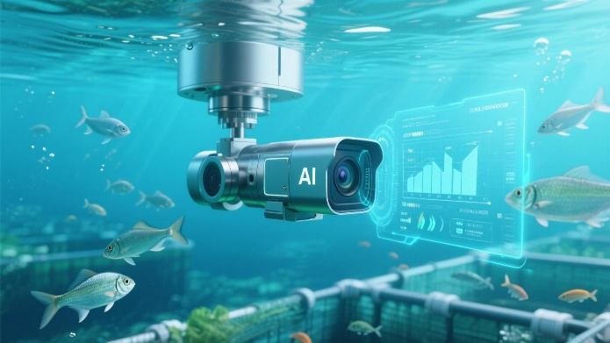
Figure 1. AI-Based Smart Aquaculture Monitoring System
1.2 Objectives of the Proposed System
- Continuously monitor fish health.
- Predict diseases using AI algorithms.
- Optimize feeding schedules based on fish behavior.
- Monitor water quality parameters such as pH, temperature, dissolved oxygen, and turbidity.
- Detect abnormal fish behavior using computer vision.
- Generate farm performance reports.
- Reduce feed wastage.
- Increase productivity and profitability.
1.3 Scope of the Problem
The system focuses on:
- Fish health monitoring
- Water quality monitoring
- Disease prediction
- Automated feed optimization
- Behavioral analysis
- Farm performance reporting
- Alert generation
- Decision support for farmers
The system does not include fish breeding management, fish marketing, transportation, or supply chain management.
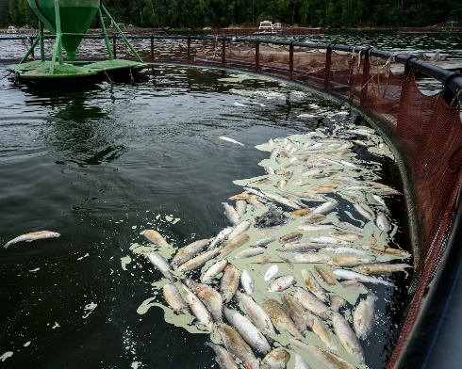
Figure 2. Disease Outbreak and Poor Water Quality in Aquaculture

2. Identify Key Stakeholders and Challenges
2.1 Stakeholders
Stakeholder | Role
Fish Farmers | Monitor fish, manage feeding, respond to alerts
Farm Managers | Supervise operations and analyze reports
Veterinarians | Diagnose diseases and recommend treatment
Farm Workers | Feed fish, maintain equipment, monitor ponds
AI System Administrator | Maintain AI models and software
IoT Sensor Providers | Supply and maintain sensors
Government Fisheries Department | Monitor standards and compliance
Customers | Receive healthy and quality fish products

2.2 Roles and Responsibilities
Fish Farmers
- Monitor daily activities
- View AI recommendations
- Take corrective actions
Farm Managers
- Analyze productivity reports
- Improve operational efficiency
Veterinarians
- Verify AI disease predictions
- Recommend medicines
Farm Workers
- Feed fish
- Maintain water quality
- Inspect sensors
System Administrator
- Update software
- Train AI models
- Manage user accounts
IoT Providers
- Install sensors
- Perform maintenance
- Ensure accurate data collection
Government Authorities
- Verify environmental compliance
- Monitor fish health standards

2.3 Challenges Faced
Farmers
- Late disease detection
- Feed wastage
- Manual monitoring
- High operational costs
Veterinarians
- Delayed diagnosis
- Lack of real-time data
Farm Workers
- Continuous monitoring is difficult
- Human errors
Managers
- Limited decision-making support
- No centralized data

3. Analyze the Current Approach
3.1 Existing System
Currently, many fish farms use manual observation.
Farmers:
- Visually inspect fish
- Measure water quality occasionally
- Feed fish at fixed times
- Detect diseases only after symptoms become severe
Records are usually maintained manually.

3.2 Strengths
- Low implementation cost
- Easy to understand
- No advanced technical knowledge required

3.3 Limitations
- No continuous monitoring
- Human errors
- Disease detected too late
- High fish mortality
- Feed wastage
- No predictive analysis
- Poor data management
- Difficult to monitor large farms

3.4 Gaps
- No AI prediction
- No automation
- No IoT integration
- No real-time alerts
- No behavioral analysis
- No smart reporting dashboard

4. Proposed Software Solution Using Software Engineering Principles
4.1 Proposed Solution
Develop an intelligent web and mobile-based aquaculture management system integrated with AI, IoT sensors, and underwater cameras.
The system continuously collects sensor data and fish images.
AI analyzes:
- Water quality
- Fish movement
- Fish feeding behavior
- Disease symptoms
The system automatically recommends:
- Feeding schedules
- Disease prevention measures
- Water quality improvements
It also generates reports and sends instant alerts.

4.2 Functional Modules
Module 1: User Management
Functions
- Login
- Registration
- User roles
- Authentication

Module 2: IoT Water Quality Monitoring
Monitor
- Temperature
- pH
- Dissolved Oxygen
- Turbidity
- Ammonia
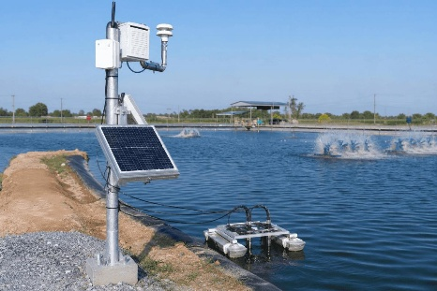
Figure 3. IoT-Based Water Quality Monitoring in Fish Farming

Module 3: Fish Health Monitoring
Features
- Underwater image capture
- Fish movement tracking
- Behavioral analysis

Module 4: AI Disease Prediction
Functions
- Image classification
- Disease prediction
- Risk scoring
- Treatment recommendation
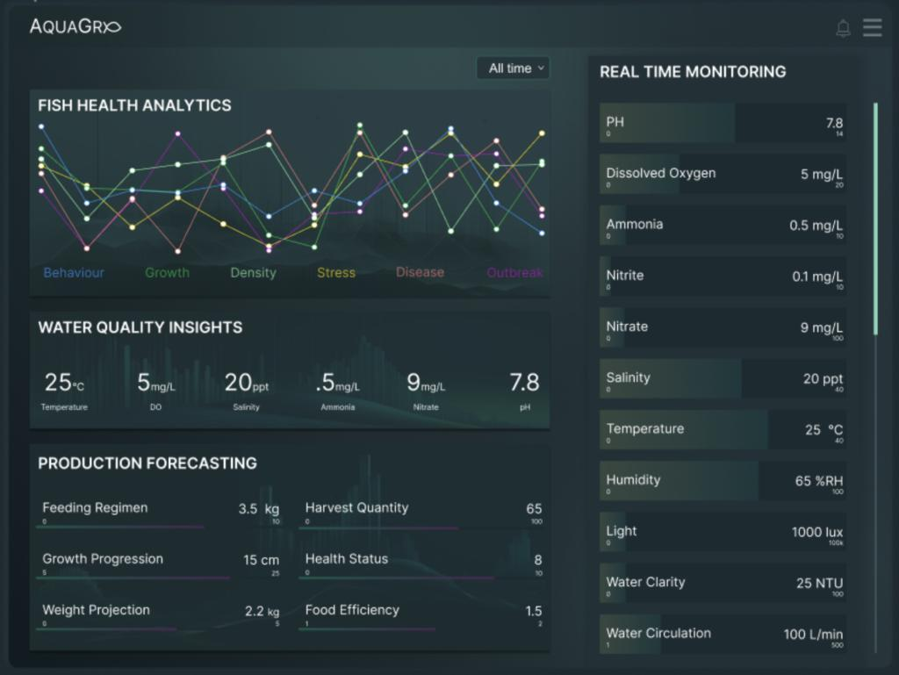
Figure 4. AI Dashboard for Fish Health Monitoring and Farm Analytics

Module 5: Feed Optimization
Features
- Analyze fish appetite
- Calculate feed quantity
- Recommend feeding time
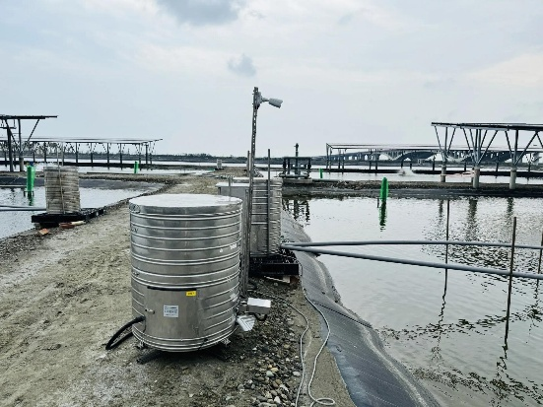
Figure 5. AI-Based Automatic Fish Feeding System

Module 6: Alert System
Notifications for
- Poor water quality
- Disease risk
- Sensor failure
- Feeding reminders

Module 7: Dashboard & Reports
Displays
- Water quality charts
- Disease trends
- Feed consumption
- Productivity reports
- Mortality reports

4.3 Functional Requirements
- User login
- Sensor data collection
- Disease prediction
- Feed recommendation
- Alert notifications
- Report generation
- Dashboard visualization
- Fish behavior monitoring

4.4 Non-Functional Requirements
Performance
- Real-time monitoring
Scalability
- Support multiple ponds and farms
Reliability
- High system availability
Security
- Secure login
- Data encryption
Maintainability
- Modular architecture
- Easy updates
Usability
- User-friendly interface
- Mobile compatibility

4.5 Software Engineering Principles Applied
Modularity
Separate modules for:
- AI
- Sensors
- Reports
- Dashboard
- Alerts

Scalability
Supports:
- More ponds
- Additional sensors
- Multiple farms

Maintainability
- Independent modules
- Easy software updates
- Bug fixes without affecting other modules

Reliability
- Sensor validation
- Backup database
- Error handling

Security
- Role-based access
- Password encryption
- Secure cloud storage

Usability
- Simple dashboard
- Graphical reports
- Easy navigation
- Mobile application support

5. Justify the Chosen Methodology
Selected SDLC Model
Agile Scrum

Why Agile Scrum?
This project requires:
- AI model improvements
- Sensor integration
- Continuous testing
- Frequent feature updates
Agile supports all these requirements.

Advantages
- Faster development
- Continuous customer feedback
- Easy requirement changes
- Better quality through frequent testing
- Lower project risk

Scrum Phases
Sprint Planning
Select features
Example
- Water monitoring
- AI prediction

Sprint Development
Develop modules

Daily Scrum
Track progress

Sprint Review
Collect farmer feedback

Sprint Retrospective
Improve next sprint

Why Agile is Suitable
Because:
- AI models improve over time.
- Sensor hardware may change.
- Farmers may request additional features.
- Frequent updates are needed.
Therefore Agile Scrum is the most appropriate methodology.

6. Expected Outcomes and Limitations
6.1 Expected Benefits
- Early disease detection
- Reduced fish mortality
- Better feed utilization
- Lower operational cost
- Increased productivity
- Improved water quality
- Better decision making
- Sustainable farming
- Increased farm profitability

6.2 How Solution Solves Challenges
Challenge | Proposed Solution
Disease outbreaks | AI disease prediction
Feed wastage | Smart feed optimization
Poor water quality | IoT sensor monitoring
Manual monitoring | Automated monitoring
Delayed response | Real-time alerts
Lack of reports | Dashboard and analytics

6.3 Risks and Limitations
- High initial installation cost
- Sensor failures
- Internet connectivity issues
- AI prediction accuracy depends on training data
- Hardware maintenance costs
- Power supply interruptions
- Cybersecurity risks

6.4 Future Enhancements
- Drone-based pond monitoring
- Blockchain for fish traceability
- Mobile application with multilingual support
- Voice assistant for farmers
- Predictive weather integration
- Automatic feeder control
- Cloud-based AI analytics
- Integration with government fisheries databases

Conclusion
The Intelligent AI-Based Smart Aquaculture Disease Prediction and Feed Optimization System is an innovative software solution that combines Artificial Intelligence, IoT, Computer Vision, and Cloud Computing to improve aquaculture management. It provides real-time monitoring, early disease prediction, optimized feeding, and detailed analytics, helping farmers reduce losses, improve productivity, and adopt sustainable aquaculture practices. By following Agile Scrum and applying software engineering principles such as modularity, scalability, maintainability, reliability, usability, and security, the proposed system is practical, efficient, and adaptable to future technological advancements.

